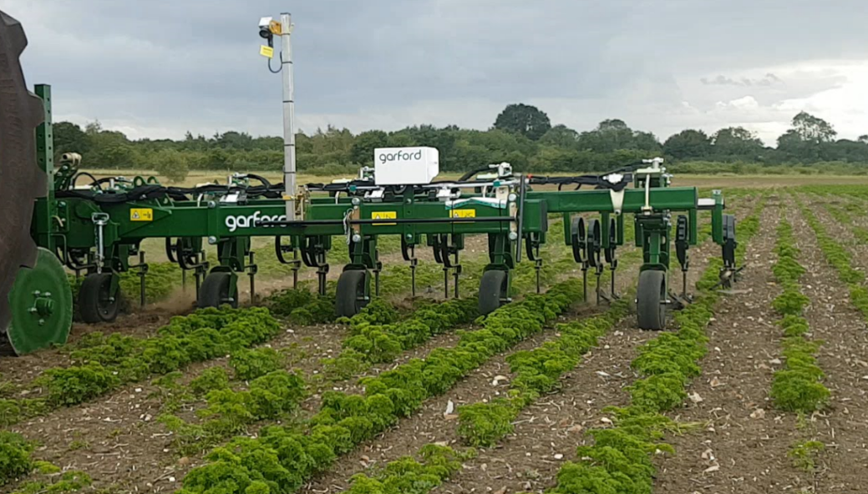

S.C Irigation Machinery S.R.L